This template format for 21st Century Local Evaluation Reports is provided to assist grantees and their local evaluators in providing evaluation findings more completely and consistently. This will allow grantees to ensure that their local report includes all the expected parts. As long as the local report includes all the needed parts and in this order, local evaluators may design the appearance. Grantees with multiple grants have the option to submit separate reports for each grant/cohort or they may include all grants/cohorts in one report as long as each grant’s/cohort’s results are displayed separately. Refer to the state evaluation report for an example of how this can be done.

[COVER PAGE]
The cover of the local report should include:
- the name of the program
- the name of the grantee and applicable cohort(s)
- the program year covered (summer + the following school year)
- The local evaluator who produced the report
- The 21st CCLC logo (below, resized as needed)

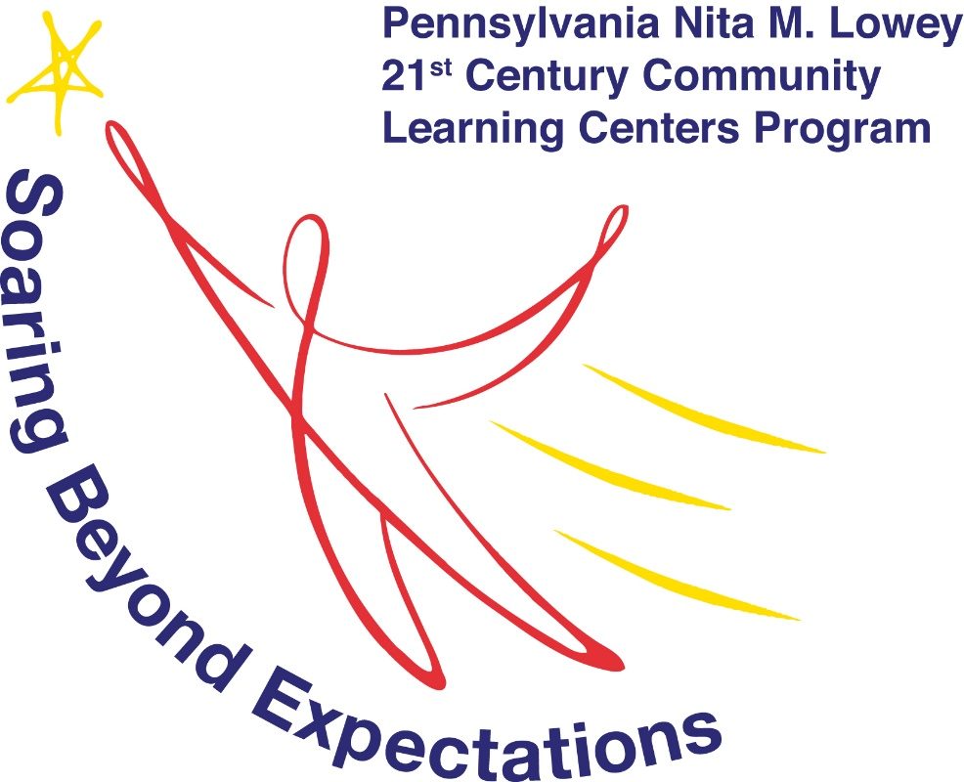

Table of Contents

Introduction 1
About Pennsylvania 21st Century Community Learning Centers 1
Program Description and Context 2
Evaluation Design 2
Findings 3
Program Design, Implementation, and Operations 3
Program Participation and Attendance 3
Student Outcomes 3
State Assessment Results 4
Grade Point Average/Classroom Performance 4
Teacher-Reported Results (Teacher Survey) 4
School Attendance 4
Student Behavior 4
Graduation and Promotion 4
High School Credit/Course Recovery 4
[Other Grantee-Defined Outcome Measures] 4
Stakeholder Feedback (if applicable) 4
Case Studies, Interviews, and Program Observations/Site Visits (if applicable) 4
Grantee Results on Performance Measures 5
GPRA Measure 1 – Academic Achievement, State Assessments 5
GPRA Measure 2 – Grade Point Average 5
GPRA Measure 3 – School Day Attendance 5
GPRA Measure 4 – Behavior 5
GPRA Measure 5 – Student Engagement in Learning 6
State Measure 6- Family Literacy and Involvement 6
Considerations and Recommendations for Improvement 7

Legislative Authority: The 21st Century Community Learning Centers is a subgrant program funded by the U.S. Department of Education, authorized by the Elementary and Secondary Education Act (ESEA) of 1965, as amended by the Every Student Succeeds Act (ESSA) of 2015, Title IV, Part B; 20 U.S.C. 7171‒7176, and administered by the Pennsylvania Department of Education.

[This table of contents can be updated automatically by hovering over the top of the Table of Contents and clicking update table. This is generated based on the heading and text types in the Styles block of the Home ribbon in Word.]

Introduction

About Pennsylvania 21st Century Community Learning Centers

The 21st Century Community Learning Centers program provides federal funding for the establishment of community learning centers that offer academic and enrichment opportunities to children, particularly students who attend high-poverty and low-performing schools, to meet state and local standards in core academic subjects through a broad array of activities that can complement their regular academic programs. Literacy and other educational services to the families of participating children must also be provided.
The 21st Century Community Learning Centers (21st Century) program is authorized under Title IV, Part B of the Elementary and Secondary Education Act (P.L. 107-110), as amended by the No Child Left Behind Act of 2001.
Pennsylvania’s primary goal for its 21st Century program is to assist youth to meet state standards for core academic subjects by providing them with academic and enrichment opportunities. In addition to academics, centers are encouraged to offer participants a broad array of other services and programs during non-school hours, such as art, music, recreation activities, character education, career and technical training, drug and violence prevention programming, and technology education. Educational services for families of participating students, such as literacy instruction, computer training, or cultural enrichment, must also be included. Federal law requires that all 21st Century program sites provide academic enrichment activities and parental involvement activities. Programs are encouraged to use innovative instructional strategies, coordinate academics with local curricula and assessments, and use assessment data to inform instruction and evaluate results. Academics are to involve more than just helping participants with homework and should not just repeat school day activities.
Pennsylvania’s 21st Century program encourages active youth and family participation to ensure that both have decision-making roles in the creation, operation, and evaluation of every 21st Century program in Pennsylvania. School and community collaboration is another key in meeting the academic, social, physical, and emotional needs of children and families. Programs are to offer quarterly open house meetings and maintain an open-door policy where adult family members feel welcome and are encouraged to drop in.
All activities are to be based on rigorous scientific research and the Pennsylvania Department of Education (PDE) provides “principles of effectiveness” to guide programs in identifying and implementing programs that enhance student learning. Activities must address the needs of local schools and communities and be continuously evaluated at the local level.

Program Description and Context

Include in this section an overview of the program, target populations, enrollment/recruitment methods, and the community/environmental context. Also included here might be a description of the needs to be addressed, an explanation of how the program came to be, and the schools/communities served by the grant.

Evaluation Design

Include in this section a description or outline of the evaluation plan, data collected and collection methods, the selection of the local evaluator, and other relevant information.

Findings

Program Design, Implementation, and Operations

In this section include information about the container within which the program was offered.
- Dates/span of operation, start and end dates
- Hours/days of operation
- Total hours of programming offered
- Operations methods (i.e. in-person, hybrid, virtual, etc.)
- Centers operated, center locations
- Activities offered, content covered
- Alignment or linkage of needs to implementation design
- Staffing
- Partners and collaborators
- Frequency and duration
- Curricula, models, and/or commercial products used
- Family engagement activities

Program Participation and Attendance

The following information should appear in this section:
- Number of students served, summer and school year
- Feeder schools/schools served
- Student demographics
- Program attendance levels (refer to 21APR attendance gradations)
- Comparison to number of students targeted to be served from application
- Counts of (adult) family members of participating students served

Student Outcomes

Student outcomes measures reporting would include the data source(s), number of students having data, grade levels included if not all, caveats and considerations, results by program attendance, building, center, grade level, cohort, duration in 21st CCLC and/or other relevant subgroups

State Assessment Results

Grade Point Average/Classroom Performance

Teacher-Reported Results (Teacher Survey)

School Attendance

Student Behavior

Graduation and Promotion

High School Credit/Course Recovery

[Other Grantee-Defined Outcome Measures]

Stakeholder Feedback (if applicable)

This would include any student, parent, partner, school leader surveys or interviews, if applicable

Case Studies and Program Observations/Site Visits (if applicable)

Grantee Results on Performance Measures

Compare actual performance/results to the grantee’s performance indicators and established GPRA and state measures, as applicable

GPRA Measure 1 – Academic Achievement, State Assessments
Percentage of students in grades 4-8 participating in 21st CCLC programming during the school year and summer who demonstrate growth in reading/language arts on state assessments.
Percentage of students in grades 4-8 participating in 21st CCLC programming during the school year and summer who demonstrate growth in math on state assessments.
Grantee Performance Indicator | Grantee’s Performance Target (# or %) | Actual Performance
[insert grantee indicator and #s/%s here, add rows as needed]

GPRA Measure 2 – Grade Point Average
Percentage of students in grades 7-8 and 10-12 attending 21st CCLC programming during the school year and summer with a prior-year unweighted GPA less than 3.0 who demonstrated an improved GPA.
Grantee Performance Indicator | Grantee’s Performance Target (# or %) | Actual Performance

GPRA Measure 3 – School Day Attendance
Percentage of youth in grades 1–12 participating in 21st CCLC during the school year and summer who:
Had a school-day attendance rate at or below 90% in the prior school year AND
Demonstrated an improved attendance rate in the current school year.
Grantee Performance Indicator | Grantee’s Performance Target (# or %) | Actual Performance

GPRA Measure 4 – Behavior
Percentage of students grades 1 - 12 attending 21st CCLC programming during the school year and summer who experienced a decrease in in-school suspensions compared to the previous school year.
Grantee Performance Indicator | Grantee’s Performance Target (# or %) | Actual Performance

GPRA Measure 5 – Student Engagement in Learning
Percentage of students in grades 1–5 participating in 21st CCLC programming in the school year and summer who demonstrated an improvement in teacher-reported engagement in learning.
Grantee Performance Indicator | Grantee’s Performance Target (# or %) | Actual Performance

State Measure 6- Family Literacy and Involvement
Number or percentage of families of participating students who participate in family literacy and involvement activities.
Grantee Performance Indicator | Grantee’s Performance Target (# or %) | Actual Performance

Considerations and Recommendations for Improvement

- Themes observed in the findings/data
- Evaluator reflections and recommendations for program improvement, prioritization
- Evaluator reflections and recommendations for evaluation/data improvement

